**GOVERNMENT OF PUERTO RICO**

**LA FORTALEZA**

**SAN JUAN, PUERTO RICO**

Administrative Bulletin Number OE-2021-028

**EXECUTIVE ORDER OF THE GOVERNOR OF PUERTO RICO, HON. PEDRO R. PIERLUISI, TO AMEND ADMINISTRATIVE BULLETIN NO. OE-2020-052 TO REQUIRE ALL PASSENGERS TO HAVE A NEGATIVE COVID-19 RESULT FROM A QUALIFIED SARS-COV2 MOLECULAR TEST AND TO DELEGATE THE DEPARTMENT OF HEALTH TO IMPLEMENT MORE RESTRICTIVE MEASURES FOR TRAVELERS COMING TO PUERTO RICO.**

**WHEREAS:**

**WHEREAS:**

**WHEREAS:**

For more than a year, Puerto Rico and the world have faced an emergency because of the COVID-19 pandemic. This situation has prompted the national and international authorities to take specific precautionary measures to safeguard people's lives. Among these measures, we can highlight the control of airports and passenger traffic.

To implement these control measures, on March 30, 2020, the governor issued Administrative Bulletin No. OE-2020-030 to establish the rules regarding the entry of passengers to airports in Puerto Rico. Subsequently, on July 3, 2020, Administrative Bulletin No. OE-2020-052 repealed the first one and relaxed those rules to a certain extent. Among other measures, he ordered a quarantine for any passenger arriving in Puerto Rico who did not present a negative result of a qualified SARS-CoV2 molecular test.

Since the enactment of that order, circumstances related to COVID-19 have changed. Despite those specific precautionary measures required by Administrative Bulletin No. OE-2021-026, infections continue to rise. Therefore, the governor amended Administrative Bulletin No. OE-2020-052 to demand that all passengers hand out a negative result for COVID-19 from a qualified SARS-CoV2 molecular test upon arrival in Puerto Rico. The order also eliminates quarantine as an option when passengers do not provide a negative result. Finally, the governor delegated to the Department of Health the power to order new restrictions regarding the entry of passengers to airports in Puerto Rico. All measures seek to control the spread of COVID-19. These new restrictions delegated to the Department include requiring --when it deems it pertinent and appropriate-- a mandatory negative result of a qualified SARS-CoV2 molecular test to all passengers



entering Puerto Rico, or a test soon as possible when arriving on our Island.

**THEREFORE:**

**SECTION 1ST:**

**SECTION 2ND:**I, PEDRO R. PIERLUISI, Governor of Puerto Rico, by virtue of the powers inherent to my office and the authority vested in me by the Constitution and the Laws of the Government of Puerto Rico, hereby declare and order the following:

Section 1st of Administrative Bulletin No. OE-2020-052 is hereby amended to read as follows:

**SECTION 1ST TRAVELER'S DECLARATION.** All passengers on a flight from any state or territory of the United States of America or any international destination must complete the Travel Declaration Form, COVID-19 alert, which they may access digitally before arrival at the following website: https://1link.travelsafe.pr.gov/. Should it not be possible to access this document electronically, the passenger may complete it in person upon arrival at the airport. The completion of the traveler’s declaration includes, among other things, attaching a copy of the negative COVID-19 result from a qualified SARS-CoV2 molecular test, as this Order requires unless the Puerto Rico Innovation and Technology Service (PRITS) and the Department of Health create an alternate electronic method. In the declaration, the passenger shall attest, under oath, that they will comply with the orders imposed concerning their behavior during their stay.

Section 2nd of Administrative Bulletin No. OE-2020-052 is hereby amended to read as follows:

**SECTION 2ND: SARS-CoV2 MOLECULAR TEST**. All passengers must wear a mask or scarf always covering the nose and mouth area upon arrival in Puerto Rico and during their stay. In addition, any passenger who, after the enactment of this order, wishes to travel to Puerto Rico through the Luis Muñoz Marín International Airport, the Mercedita International Airport or the Rafael Hernández International Airport, or any other airport on the Island, on a flight from the United States of America or any international destination must:

i. Present or show at the airport a negative COVID-19 result from a qualified SARS-CoV2 molecular test performed within seventy-two (72) hours before arrival in Puerto Rico;

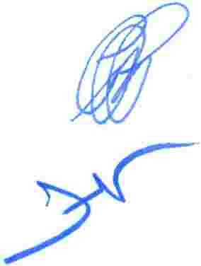

ii. In the absence of performing the molecular test before arrival in Puerto Rico, every passenger must present a negative COVID-19 result from a qualified SARS-CoV2 molecular test performed within forty-eight (48) hours of arrival. The Department of Health shall issue the pertinent regulations to enforce

the above and may impose the corresponding sanctions or fines.

iii. In the screening area that the Department of Health and the National Guard established, any passenger who presents symptoms associated with COVID-19 must strictly comply with the Department of Health’s guidelines concerning the protocol to be followed and the corresponding test to be conducted.

Any passenger who tests positive for COVID-19 will be responsible for all medical and extended stay expenses, as the traveler will have to remain in isolation until the Department of Health so determines.

All passengers must comply with the following:

a complete, upon arrival at the airport, the Department of Health's form, including the traveler's declaration, in which they must indicate personal and contact information, for proper follow-up and monitoring by the Department; and;

b. comply with all orders, instructions, protocols, and requests for information from the Department of Health, the National Guard, and any other concerned governmental entity during their stay.

Any flight crewmember or aviation mechanic who does not remain in Puerto Rico longer than seventy-two (72) hours, federal agents, activated military personnel, and any other personnel the Department of Health may determine shall be exempt from complying with the provisions of this order.

**SECTION 3RD:** Section 3rd of Administrative Bulletin No. OE-2020-052 is hereby amended to read as follows:

**SECTION 3RD: COMPLIANCE.** In coordination with the National Guard, the Ports Authority, the Department of Public Safety, and any other government entity it deems pertinent, the Department of Health shall take the necessary measures to implement the provisions of this order. These measures establish the specific protocol concerning the details of each passenger's information collection process. It also sets forth how the governmental authorities shall handle traveler's information and the due notification of the provisions contained in this order and each passenger's rights, including the strictest confidentiality in handling the data. The governor has hereby delegated the Department of Health the power to impose more severe restrictions through the appropriate legal mechanisms beyond those set in this order if the contagion levels so warrant.

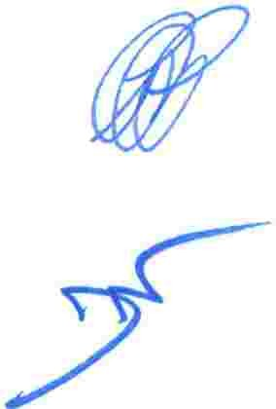

No passenger may leave the airport facilities without having completed the process established by the Department of Health, in coordination with the Puerto Rico National Guard, under the provisions of this order, which includes the completion of the traveler's declaration form.

The Puerto Rico Tourism Company (PRTC) and the Ports Authority shall establish communication with travel agencies, airlines, and the hotel industry to collaborate in the proper notification of passengers regarding the requirements for travel to Puerto Rico.

**SECTION 4TH:** Section 4th of Administrative Bulletin No. OE-2020-052 is hereby amended to read as follows:

**SECTION 4TH: WARNINGS.** Each passenger must attest, under oath, on the form, they complete with their personal information that they comply with the orders provided for in the form concerning their stay. The passenger must interact directly with the Department of Health surveillance systems and comply with the information requirements requested digitally, through calls, or in person. Should any person not comply with the provisions contained in this executive order, criminal penalties and fines established by the provisions of Act No. 20-2017 shall be applied. Act No. 20-2017 contemplates a sentence of imprisonment not to exceed six (6) months or a fine not to exceed five thousand (5,000) dollars or both penalties at the court's discretion or any applicable law. Likewise, according to the provisions of Section 33 of the Department of Health Act, "[a]ny natural or juridical person who violates the provisions of this Act or the regulations issued by the Department of Health thereunder shall be guilty of a misdemeanor and punishable by imprisonment not exceeding six (6) months or a fine not exceeding five thousand ($5,000) dollars, or both penalties at the discretion of the court." Moreover, the Department of Health may file administrative complaints against those natural or juridical persons who fail to comply with the provisions of this executive order and jeopardize the health and safety of the citizenry, according to the provisions of Chapter 7, Section 7.1 of Act No. 38-2017, as amended, known as the Uniform Administrative Procedure Act of the Government of Puerto Rico.

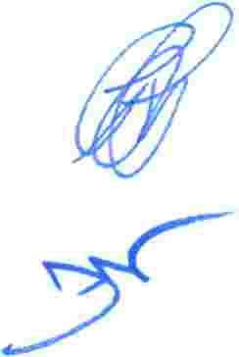

The provisions of this executive order shall continue in full force and effect even when the government repeals the curfew established in Administrative Bulletin No. OE-2021-026 and subsequent orders.

**SECTION 5TH:**

**SECTION 6TH:**

**SECTION 7TH**

**SECTION 8TH:**

**SECTION 9TH:**

**:**

**SEVERABILITY.** The provisions of this Executive Order are separate and independent from each other, and if any part, section, provision, or sentence of this Executive Order is held to be unconstitutional, void, or invalid by a court with competent jurisdiction, such holding shall not affect the validity of the remaining provisions, which shall remain in full force.

**NON-CREATION OF ENFORCEABLE RIGHTS**. This executive order is not intended to create any rights, substantive or procedural, enforceable at law or equity, by any person or entity, in any matter, civil, criminal, or administrative, against the Government of Puerto Rico or its agencies, officials, employees, or any other person.

**REPEALING CLAUSE.** This Executive Order renders ineffective any parts of such other executive orders that are inconsistent, whether in whole or in part, with the provisions herein to the extent of such inconsistency.

**VALIDITY AND TRANSITION.** This Executive Order shall take effect immediately. However, as a transitional measure, the regulations promulgated under Administrative Bulletin No. OE-2020-52 will continue to be in effect until the Department of Health issues the guidelines replacing them.

**PUBLICATION.** This Executive Order must be filed immediately with the Department of State and the broadest possible publication is hereby ordered.

|  |  |
| --- | --- |
|  | **IN WITNESS WHEREOF,** I hereby issue this Executive Order under my signature and cause the Great Seal of the Government of Puerto Rico to be affixed, in La Fortaleza, San Juan, Puerto Rico, on this 16th day of April 2021.    **PEDRO R. PIERLUISI**  **GOVERNOR** |

Promulgated in accordance with the law on this 16th day of April 2021.

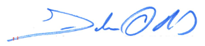

**FELIX E. RIVERA TORRES**

**ACTING SECRETARY OF STATE**