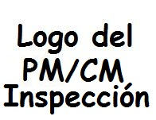
Name Public Housing, City, PR
(RQ-00####)
Nombre del Autor
Puerto Rico Public Housing Administration
6/1/2017
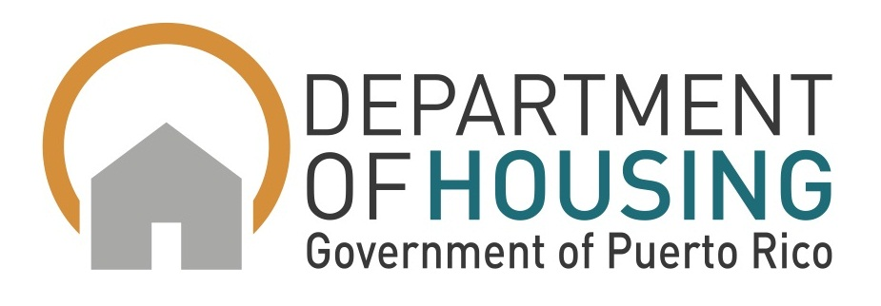
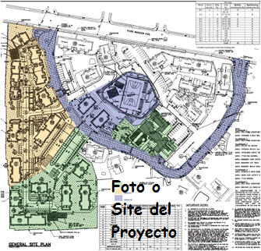
Form AVP-500380
Rev. June 2017
Constructability Review

Constructability Review
PROJECT: Name of Project Public Housing, City, Puerto Rico RQ-00####
Contents
1. INTRODUCTION 3
2. Project Profile 3
2.1. Project Description 3
2.2. Total Development Cost 5
2.3. Proposed Contract Time 7
2.4. Permits 7
2.5. Revisions 9
2.5.1. Site Visit and Meetings 9
2.5.2. Project Cost 10
2.6. Site Plan Description and View 11
2.6.1. Location Plan 11
2.6.2. Zoning Plan 11
3. Project Phases 12
3.1. Phase Plan 12
3.2. Building by Phase 12
4. Regulatory Compliance Activities 12
4.1. Davis Bacon Act (DBA) 12
4.2. Section 3 13
4.3. HUD Section 504 Compliance Report 13
4.4. Asbestos and Lead Abatement Activities 14
4.4.1. Abatement 15
5. Resident Relocation Activities 15
5.1. Planning 15
6. Description Of Potential Problems That Need To Be Addressed. 17
7. ATTACHMENTS 19
7.1. ATTACHMENT A – Notice to Proceed 21
7.2. ATTACHMENT B - CPM 23
7.3. ATTACHMENT C - REVISION AND COMMUNICATIONS 25
7.4. ATTACHMENT D - CD PROPOSED SPECIFICATIONS 27
7.5. ATTACHMENT E – CONSTRUCTION ESTIMATE COST 29
7.6. ATTACHMENT F - EASEMENT 31

Constructability Review
PROJECT: Name of Project Public Housing, City, Puerto Rico RQ-00####

INTRODUCTION
On Month ##, 20##, PM/CM/Inspection Name (CMN) executed a contract with PRPHA in order to provide Construction Management and Inspection services for the comprehensive modernization program. A notice to proceed (NTP) dated Month ##, 20## was provided to CMN for the constructability review services at Name of Project Public Housing (RQ-00####) in the Municipality of City. (Attachment A) These services will be in accordance with Contract Number 20##-000###.

Project Profile

Project Description
The proposed project consists of the comprehensive modernization of number (###) existing dwelling units and additional number (###) dwelling units to be painted from the previous modernization project. The renovation of the Head Start and Administration/Community building is part of the modernization scope of work. The existing dwelling units’ distribution to be renovated is as follows: number (##) units of one (1) bedroom, number (##) units of two (2) bedroom, number (##) units of three (3) bedroom, number (##) units of four (4) bedroom, and number (##) units of five (5) bedroom.

The scope of work includes: lead and asbestos abatement and disposal, selective demolitions, construction of new stairs, replacement of doors and windows, bathroom fixtures, kitchen cabinets, walls ceramic tiles, floor finishes, plumbing, electrical & telephone systems, painting, grillwork, and roofing membranes, as well as utility site improvements and new parking areas.

Number (##) buildings for total of number (##) existing dwelling units have been impacted by a previous Contractor from a prior modernization program, where each building was abandoned without being completed. There are number (##) row houses buildings that require floor and roof demolition. During the previous modernization, a partial demolition was performed on the second floor and roof, compromising the structural integrity of the slabs. These buildings are the most critical to be remodeled.

The asbestos abatement activity will impact number (##) buildings. Buildings ##, ##, ##, and Administration will be subjected to asbestos abatement at phase one (1). Buildings ## and ## will be subjected to asbestos abatement at the last phase of the modernization. The lead abatement will impact one dwelling unit at building number (##).

The site work will include the construction of one hundred number (##) new parking spaces, garbage stations, accessible routes, playground area, concrete fence and a walking path for exercise. Electrical, water, sanitary, and storm sewer improvements will also be performed. The main street will be milled and restored with asphalt.

Total Development Cost
The Total Development Cost (TDC) limit for the modernization of existing public housing units will be ninety (90) percent of the TDC for the development of new units. According to Table #1 below 90% of the TDC for the modernization of these number (##) Units is $##,###,###.##.

Table #1 – 90% TDC for the Development of new units.
Building Number | Building Type | No. of Stories | 1 Bedroom | 2 Bedroom | 3 Bedroom | 4 Bedroom | 5 Bedroom | # of Apartments
1 | Walk Up | 3 |  | 6 |  |  |  | 6
7 | Walk Up | 2 | 12 |  |  |  |  | 12
8 | Walk Up | 3 | 18 |  |  |  |  | 18
11 | Walk Up | 3 |  | 6 |  |  |  | 6
12 | Walk Up | 3 | Ejemplo |  | 6 |  |  | 6
13 | Walk Up | 3 |  |  | 6 |  |  | 6
15 | Row-Houses | 1 |  |  |  | 4 |  | 4
16 | Walk Up | 3 |  |  | 12 |  |  | 12
17 | Row-Houses | 1 |  |  |  |  | 4 | 4
19 | Walk Up | 3 |  | 6 |  |  |  | 6
21 | Walk Up | 3 |  | 6 |  |  |  | 6
22 | Walk Up | 3 |  | 6 |  |  |  | 6
23 | Row-Houses | 1 |  |  |  |  | 4 | 4
24 | Row-Houses | 1 |  |  |  |  | 4 | 4
25 | Walk Up | 3 |  |  | 12 |  |  | 12
 | Adm Bldg | 2
 |  |  | 30 | 30 | 36 | 4 | 12 | 112
TDC-Row Houses |  |  |  |  |  | $340,088 | $375,289
TDC-Walk Up |  |  | $165,248 | $209,335 | $272,845
Total TDC |  |  | $4,957,440 | 6,280,050 | $9,822,420 | $1,360,352 | $4,503,468 | $26,923,730
90% Total TDC |  |  |  |  |  |  |  | $24,231,357

The TDC for the previous modernized number (##) units which are proposed to be painted during this modernization is $##,###,###.##. These calculations are based on 20## Unit Total Development Cost (TDC) Limits (See Table #2 below).

Table #2 – TDC – Buildings to be Painted – 186 Units
Building Number | Building Type | No. of Stories | 1 Bedroom | 2 Bedroom | 3 Bedroom | 4 Bedroom | 5 Bedroom | # of Apartments
2 | Walk Up | 3 |  |  | 12 |  |  | 12
3 | Walk Up | 3 |  | 6 |  |  |  | 6
9 | Walk Up | 3 |  | 6 |  |  |  | 6
4 | Walk Up | 3 |  | 6 |  |  |  | 6
5 | Walk Up | 3 | 18 |  |  |  |  | 18
10 | Walk Up | 2 |  |  |  | 6 |  | 6
6 | Walk Up | 2 | 8 |  |  |  |  | 8
14 | Walk Up | 2 |  |  |  | 6 |  | 6
18 | Walk Up | 3 |  | 6 |  |  |  | 6
20 | Walk Up | 3 |  | 6 |  |  |  | 6
27 | Walk Up | 3 |  | 6 |  |  |  | 6
26 | Walk Up | 2 |  |  |  | 6 |  | 6
28 | Walk Up | 3 | Ejemplo | 6 |  |  |  | 6
29 | Walk Up | 3 |  | 6 |  |  |  | 6
30 | Walk Up | 3 |  | 6 |  |  |  | 6
31 | Walk Up | 3 |  | 6 |  |  |  | 6
32 | Walk Up | 3 |  |  | 12 |  |  | 12
33 | Walk Up | 2 |  |  |  | 4 |  | 4
34 | Walk Up | 3 |  |  | 12 |  |  | 12
35 | Walk Up | 3 |  | 6 |  |  |  | 6
36 | Walk Up | 3 |  |  | 12 |  |  | 12
37 | Walk Up | 3 |  | 6 |  |  |  | 6
38 | Walk Up | 3 |  | 6 |  |  |  | 6
39 | Walk Up | 3 | 12 |  |  |  |  | 12
 |  |  | 38 | 78 | 48 | 22 |  | 186
 |  |  | $165,258 | $209,335 | $272,846 | $340,032
Total TDC |  |  | $6,279,804 | $16,328,130 | $13,096,608 | $7,480,704 |  | $43,185,246.00
90% TDC of 186 units |  |  |  |  |  |  |  | $38,866,721.40
90% TDC of 112 units |  |  |  |  |  |  |  | $24,231,357.00
 |  |  |  |  |  |  |  | $63,098,078.40

PRPHA must verify previous funding allocation in order to determine funding availability for this Modernization.

Proposed Contract Time

CMN proposed four construction phases for the Modernization. The first phase includes the modernization of number (##) buildings for a total of number (##) dwelling units including Administration/Community/Head Star Building. The second phase includes the modernization of number (##) buildings for a total of number (##) dwellings units. The third phase includes number (##) buildings for a total of number (##) dwelling units, new recreational facilities, and main street work. The fourth phase considers the exterior painting of the previous number (##) modernized buildings for a total of number (##) dwelling units. Phase four activities have been programmed to start with the modernization of Phase 2.
The project’s critical path is as follows: buildings ##, ##, and ## from phase one, and buildings ## and ## from phase 3. The modernization of buildings ## and ## depends on the completion of Administration/Community/Head Star Building.
The estimated project duration is number (##) calendar days. See attachment (See Attachment B)

Permits
This project involved eighteen different agencies for endorsement or permits approval. (See Table 3)

Table #3 Permit Status
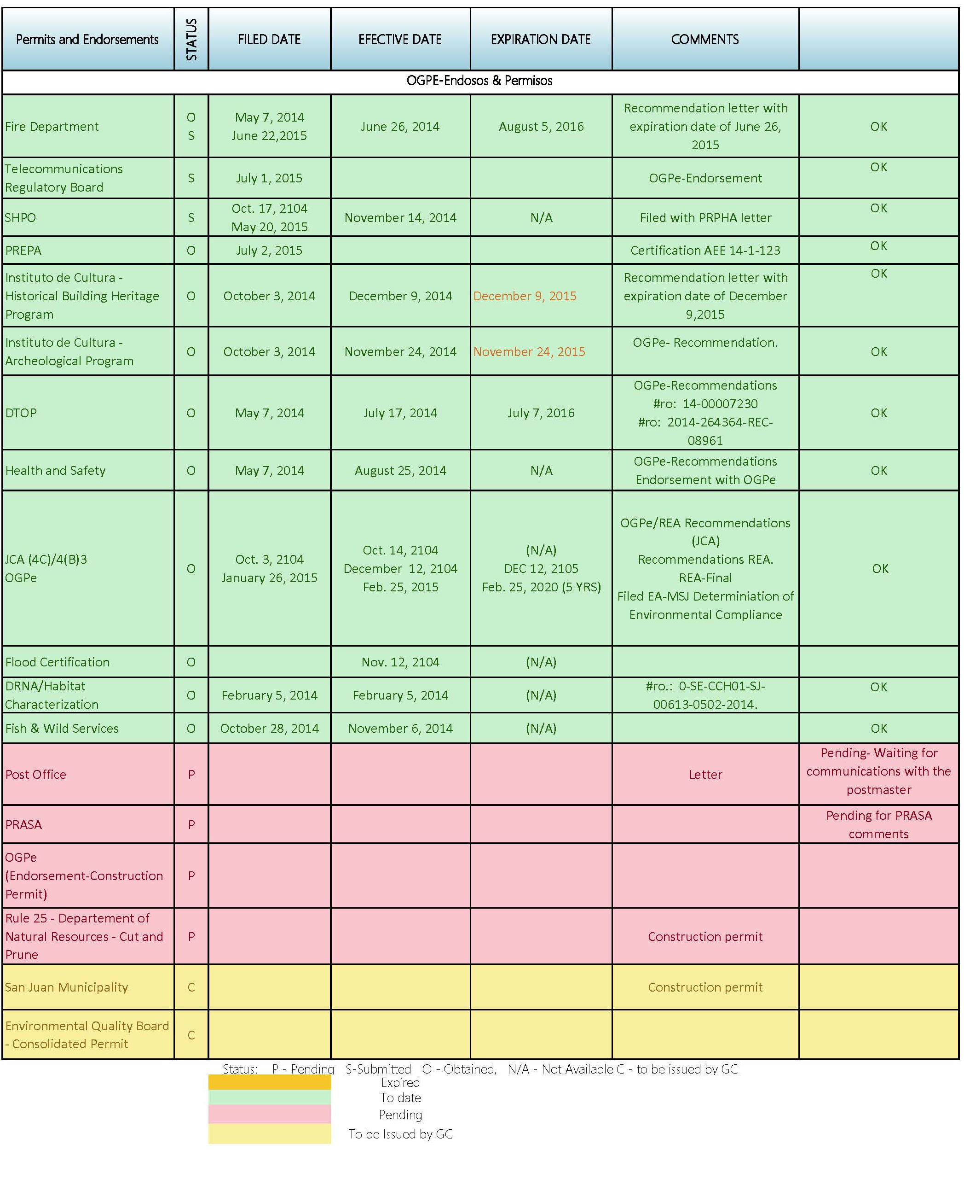
Ejemplo

The most critical endorsement as of today is PRASA’s. Final plans and revisions have been submitted by project’s designer, Design Firm Name for PRASA’s review and endorsement. This endorsement is necessary in order to obtain final permitting for the project. PRPHA assistance and follow up is needed in order to complete this process.
There are two permits from the “Instituto de Cultura” which will expire on November and December 20##.

Revisions
An initial set of drawings and specifications was reviewed by CMN Staff. Several meetings were conducted with Eng. Name designer from Designer Firm Name, and PRPHA personnel in order to discuss the revisions and any other relevant information that need to be addressed by PRPHA. We are including all the revisions and communications on Attachment C. Currently, we received an amended final set of drawings that is under evaluation.

The general, supplemental, and special conditions for this project has been reviewed by our staff. As part of the revision we incorporated additional clauses to these documents for PRPHA review and approval. We include a CD with the proposed specifications, see attachment D.

Site Visit and Meetings

Meeting Dates - Constructability Review Name of Project
1 | Thursday, July 9, 20## | Visit to Name of Project meeting with administration staff and Board of Residents. DESIGN FIRM NAME participated on this meeting.
2 | Monday, July 13, 20## | Meeting at CMN to discuss Constructability Review.
3 | Wednesday, July 15, 20## | Meeting at PRPHA with PRPHA personnel. (Design and Construction Department)
4 | Friday, July 17, 20## | Site Visit to view existing conditions of Name of Project.
5 | Tuesday, August 4, 20## | Meeting at CMN for findings evaluation.
6 | Thursday, August 6, 20## | Meeting at CMN to discuss and clarify findings with DESIGN FIRM NAME Eng. Designer Name.
7 | Tuesday, August 11, 20## | Meeting at PRPHA to discuss Constructability Review Findings with PRPHA personnel. DESIGN FIRM NAME participated on this meeting.
8 | Thursday, September 3, 20## | Meeting at CMN for Specification’s Revision and Evaluation.
9 | Thursday, September 10, 20## | Meeting at CMN to discuss revision current status, additional findings and specifications. Eng. Designer Name participated at this meeting.
10 | Friday, September 11, 20## | Meeting at CMN to discuss general, supplemental, and special conditions with PRPHA.

Project Cost

Designer
Original Design Cost : $###,###.##
Change Orders Cost : $ ##,###.##
Revised Cost : $###,###.##
Certified Work : Pending
% certified work : Pending
Design start date : Month ##, 20##
Original Contract time : #### calendar days
Revised Contract time : #### calendar days
Design ending date (Original) : Month ##, 20##
Revised ending date : Month ##, 20##
% of design services completed time : ##%

Construction Estimate Cost
The construction estimates for this project is $##,###,###.## including several allowances that need to be included with the Bid Documents. (See attachment E).

The cost estimate does not consider the increase in wages. According to General Decision Number 01/02/20## PR3, the wage determination has increased labor salaries approximately ##%, which represent $#,###,###.00.

Site Plan Description and View
Name of Project is located between the intersection of Street Name Avenue and Other Street near the intersection of PR ## (Name Main Street), a major east west, and PR ## (Name Main Street).

Location Plan
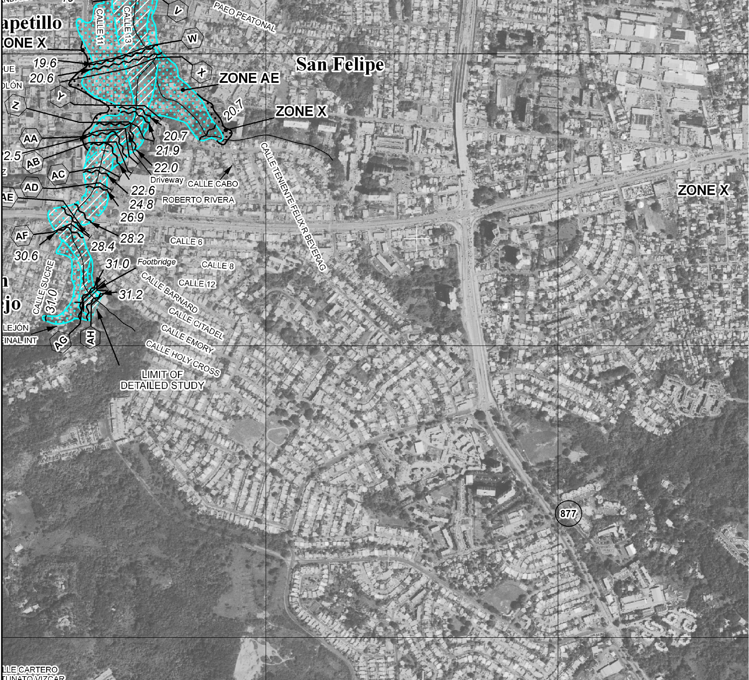

Zoning Plan
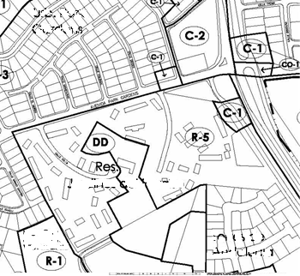

Project Phases

Phase Plan
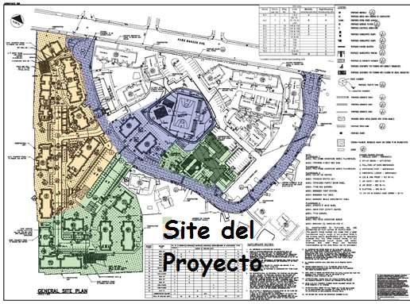

Building by Phase
FASE I | FASE II | FASE III | FASE IV
19 | 16 |  | Paint Bldg. 2, 3, 9, 4, 5 and 10
24 | 17 |  | Paint Bldg. 14, 37, 6, 38, 39 and 18
23 | 15 | Ejemplo | Paint Bldg. 20, 27, 28, 26, 29 and 31
22 | 11 |  | Paint Bldg. 36, 35, 34, 33, 32 and 30
25 | 7 & 8 | Playground & Fitness Course
21 | 1
ADM |  | 12 & 13

Regulatory Compliance Activities

Davis Bacon Act (DBA)
The Davis-Bacon Act requires the payment of prevailing wage rates determined by the U.S. Department of Labor to all laborers and mechanics on federal construction projects in excess of $2,000.00. Construction includes alteration and/or repair, including painting and decorating of public buildings or public works. Since month ##^{h}, 20##, CMN is responsible for the implementation of DBA policy.

The Bid Package for this project includes the most recent wage rates, General Decision Number: PR150003 01/02/20## PR3. (For reference see Construction Forms Section at the CF-043)
Article 29. Additional Requirements for compliance with labor standard laws has been added to the Special Conditions.

Section 3
Section 3 requirement is included in the Bid Package of this project, for references see the following sections:
- General Requirements, item 6.
- Special Conditions, section 11, Resident Employment.
- HUD-5369-A – Representations, Certifications, and Other Statements of Bidders (See Bid Form Section BF-017)
- HUD-5370 – General Conditions of contractor for Construction (See Bid Form Section BF-018)
- HUD-5369 Instructions to Bidders for Contracts (See Bid Form Section BF-016)

HUD Section 504 Compliance Report
Name of Project Public Housing Project consists of a total of Number (##) units. According to the Uniform Federal Accessible Standards and Section 504, PRPHA is required to comply with a 5% of the total units of the project to be assigned for accessible units, 1% of the total units assigned for the hearing impaired and 1% for the visual impaired. Although the proposed project consists of the modernization of number (##) dwelling units, the drawings specified the construction of number (##) units for mobility impairment and Number (##) units for sight/hearing impairment. This exceeds the UFAS and ADA’s compliance. Below Table 4 show the proposed units for 504 Compliance.

Table 4: Designated Handicapped
Building Number | Apartment Number | Accessibility impairment
1 | 1 | Mobility
1 | 2 | Mobility
8 | 69 | Mobility
8 | 70 | Mobility
8 | 75 | Mobility
8 | 76 | Mobility
8 | 81  Ejemplo | Mobility
8 | 82 | Mobility
19 | 149 | Mobility
19 | 150 | Mobility
22 | 167 | Mobility
22 | 168 | Mobility
12 | 105 | Mobility
12 | 106 | Mobility
13 | 111 | Mobility
13 | 112 | Mobility
7 | 57 | Sight / Hearing
7 | 58 | Sight / Hearing
16 | 134 | Sight / Hearing
15 | 126 | Sight / Hearing
23 | 176 | Sight / Hearing
5* | 44 | Sight / Hearing
3* | 19 | Sight / Hearing
3* | 20 | Sight / Hearing
*Units located on previous modernized buildings.

The drawings and specifications comply with UFAS and 504 Section guidelines.

Asbestos and Lead Abatement Activities
The asbestos abatement activity will impact number (##) buildings. Buildings ##, ##, ##, ##, and Administration will be subject to asbestos abatement at phase one (1). Buildings 12 and 13 will be subject to asbestos abatement at the last phase of the modernization. The lead abatement will impact number (##) dwelling unit at building twenty on number (##).

There is presence of pearltex at buildings ##, ##, ##, ##, and Administration’s ceilings. The window and door frames contain caulking at building ##, ##, ##, ##, and 22.

The Apartment ### contains lead base paint material. This unit is located at building ##.

The most recent environmental specifications did not consider any activity at the site. CMN recommend to include an allowance for this purpose on the Bid Package.

Abatement
The actual status of the abatement activity is as follows:
Ejemplo
Total Buildings for abatement activities | 6
Total Dwelling Units for abatement activities | 28

Resident Relocation Activities

Planning
The Relocation activity shall take place for the modernization of the 112 dwelling units. As of Month 20##, this section of the project has number (##) vacant units. The number (##) dwelling units with no vacancy are located on buildings ## and ## which have been used for the temporary occupancy of the Administration and Head Start. (See table #5)

The actual status of the relocation is as follows:
Table #5 Actual Relocation
NAME OF PROJECT - 112 UNITS
Building # | Building Type | # of Apartments |  | Comments
1 | Walk Up | 6 | Vacancy
7 | Walk Up | 12 | Vacancy
8 | Walk Up | 18 | Vacancy
11 | WALK UP | 6 | Vacancy
12 | Walk Up | 6  Ejemplo | No Vacancy | At the moment this building is used for Administration Office
13 | Walk Up | 6 | No Vacancy | At the moment this building is used for as Headstart Facilities.
15 | Row-Houses | 4 | Vacancy
16 | Walk Up | 12 | Vacancy
17 | Row-Houses | 4 | No Vacancy | At the moment this building is illegally occupied.
19 | Walk Up | 6 | No Vacancy | At the moment this building is illegally occupied.
21 | Walk Up | 6 | Vacancy
22 | Walk Up | 6 | No Vacancy | At the moment this building is illegally occupied.
23 | Row-Houses | 4 | Vacancy
24 | Row-Houses | 4 | Vacancy
25 | Walk Up | 12 | Vacancy
 | ADM BLDG
 |  | 112

Description Of Potential Problems That Need To Be Addressed.
- The most critical endorsement as of today is PRASA’s. Final plans and revisions have been submitted by DESIGN FIRM NAME for PRASA’s review and endorsement. This endorsement is necessary in order to obtain final permitting for the project. Assistance and follow up from PRPHA is needed in order to complete this process. The endorsement must be issued before the Notice to Proceed is given to the General Contractor.

- PRPHA is considering the exterior painting of number (##) dwelling units. There is a possibility that an issue may arise regarding the warranty for this work due to leaks on the existing waterproofing treatment.

- The general, supplemental, and specials conditions has been reviewed and edited. This document are included for PRPHA review and approval.

- Buildings ##, ##, ##, ##, and ## have been illegally occupied. These occupancies need to be vacant before the General Contractor’s Notice to Proceed is being issued.

- Final drawings are under evaluation; final revision should be completed by Month ##th.

- PRPHA must assignee budget for several activities that must be included in the Bid Documents as Allowances. This quantity has been considered in the estimate. This information could be submitted as Project Addenda.
- PRPHA needs to verify the status of the previous PREPA electric service distribution system easements registration. Apparently, this process started on Month ##, 20##, but we can’t conclude that registration has been completed. (See Attachment F)

ATTACHMENTS

ATTACHMENT A – Notice to Proceed

ATTACHMENT B - CPM

ATTACHMENT C - REVISION AND COMMUNICATIONS

ATTACHMENT D - CD PROPOSED SPECIFICATIONS

ATTACHMENT E – CONSTRUCTION ESTIMATE COST

ATTACHMENT F - EASEMENT

